When you first open the Attendance Report in Word 2007, you will get a Security Warning dialog as seen in the screenshot below:
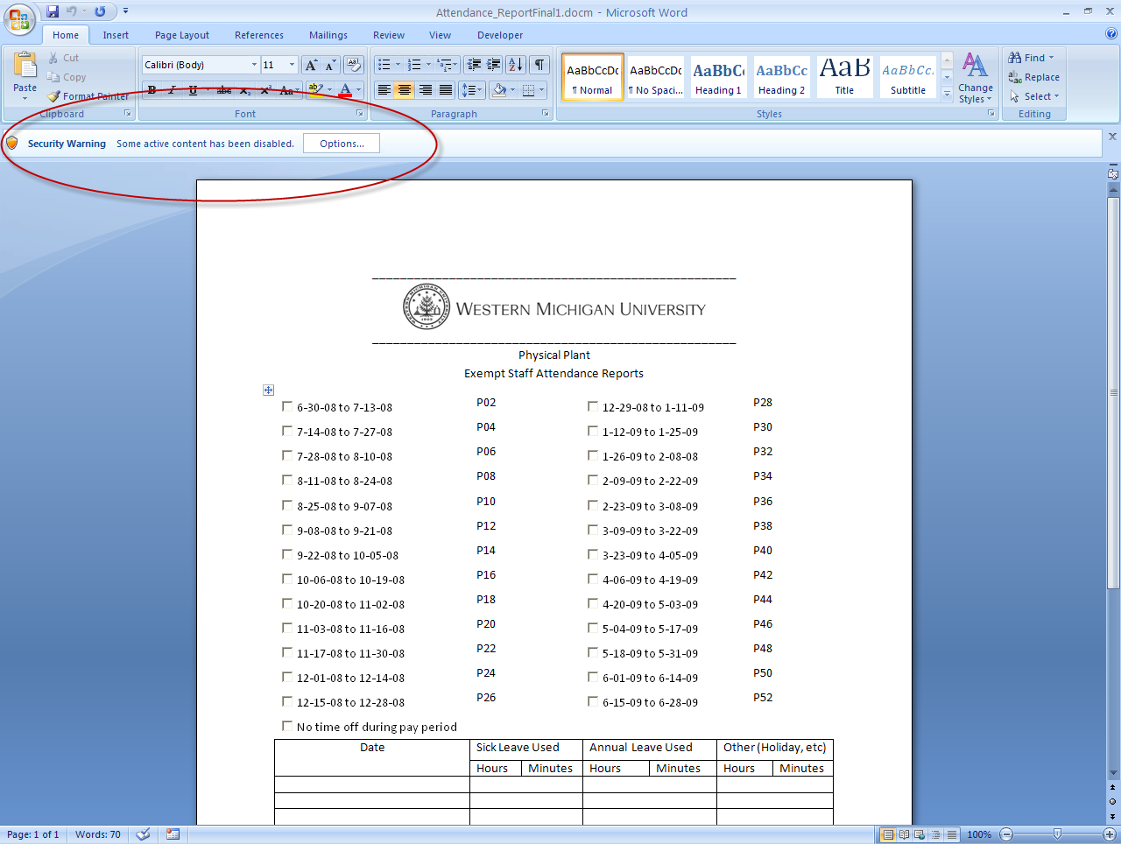
Click on the Options button and you will see this dialog box: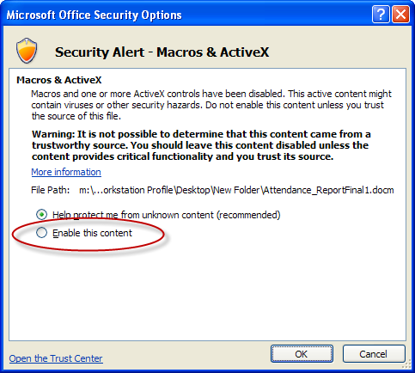
Select the radio button next to Enable this content and click OK, as seen in the following dialog box:
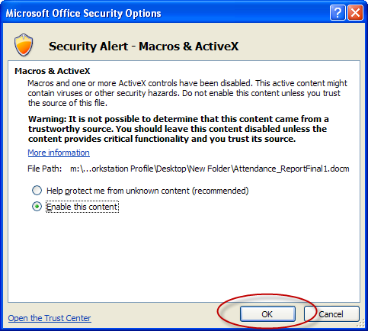

After clicking OK, it is not uncommon for it to take several seconds to apply the changes, at which point your screen might go white briefly. After that is done, you are able to fill out the form as you need.

